2022


QA Task
2022
Car Rental Management System
Date: 5/27/2022
Name: Abdullah Aldughaimi

Table of Contents
Abstract 3
2. Testing and Verification (Manual Testing) 4
3. Testing and Verification (Automation Testing) 10
Test 1 File (Sign Up Page) 10
The output 13
Test 2 File (Sign Up Page) 13
The output 15
Test 3 File (Login Page) 15
The output 17
References 18

Abstract
The car rental management system provides an environment to book vehicles and pay online efficiently. It is a user-friendly system, and it is simple to use. The car rental management system is very convenient for various reasons. For example, the user does not need to call or physically go to the site to book the car they want. They can simply go to the website and finish everything online. The system was implemented using many great tools to make the system user-friendly and with great functions. First of all, HyperText Markup (HTML) Language to structure a web page. Secondly, Cascading Style Sheets (CSS) to design the pages. Thirdly, JavaScript for implementing the functions for the pages. Fourthly, PHP for implementing the backend side of the website. Lastly, phpMyAdmin to connect our MySQL database and host the website. Eventually, I will test the system using test cases and TestCafe.

Testing and Verification (Manual Testing)
      - Login Page:
- If the user enters a wrong email address.
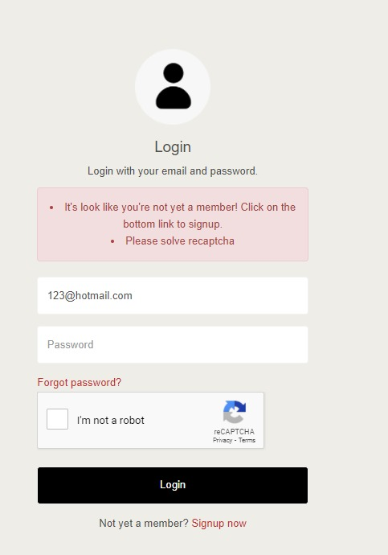
Figure 1: Wrong Email Address Error
- If the user enters a valid email address, but enters the wrong password.
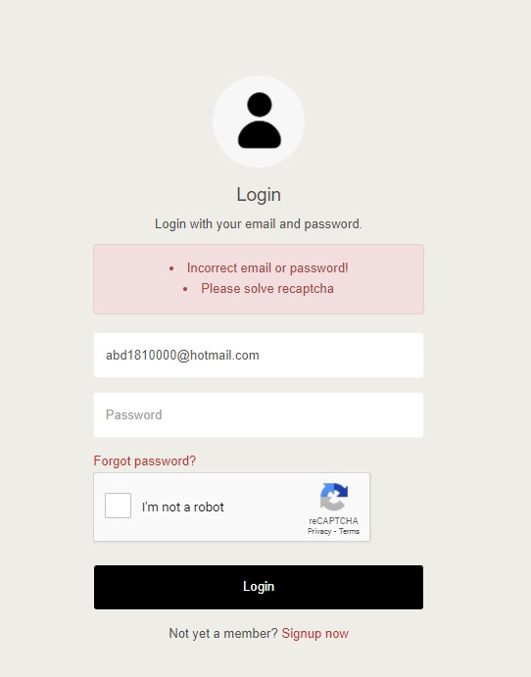
Figure 2: Wrong Password Error
- If the user enters a valid password and email without solving reCAPTCHA.
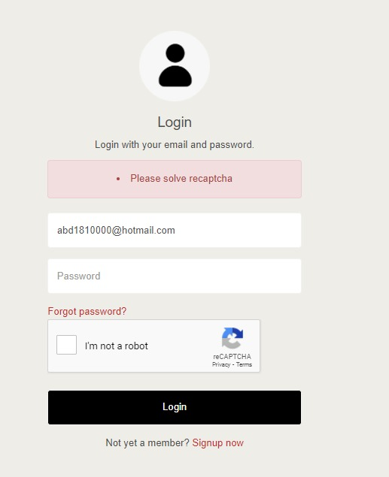
Figure 3: reCAPTCHA Error
- Otherwise, the page will be directed d to the home page. Also, the user can see his/her email top right of the page.
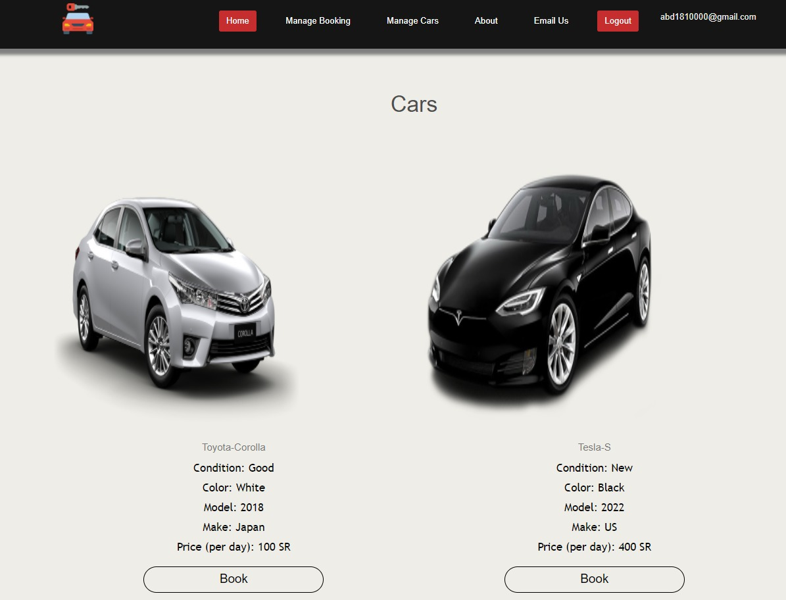
Figure 4: Home page
      - Signup Page: Note that all users should be verified to log in. Otherwise, the user will not be able to log in.
- Passwords should be 1 letter, 1 digit, and a minimum of 8 characters.
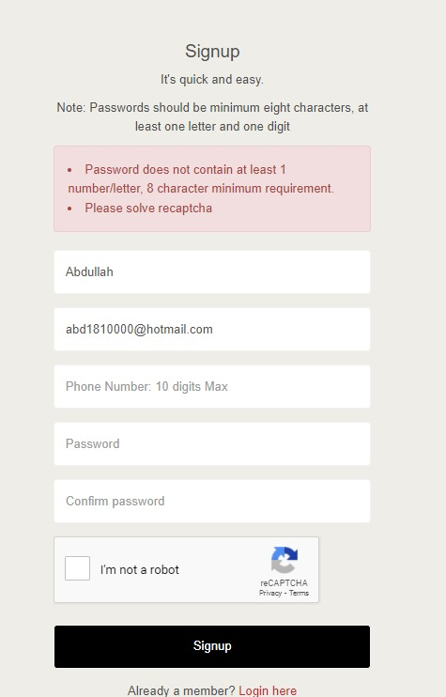
Figure 5: Password Format Error
- The phone number should be only numbers and a maximum of 10 numbers.
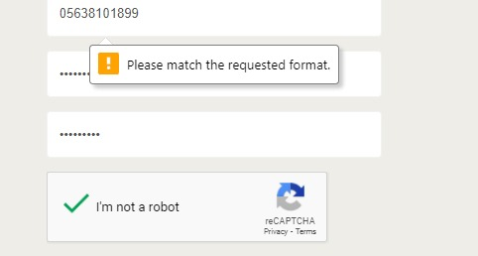
Figure 6: Phone Number Format
- The email or phone number should not already exist in the database.
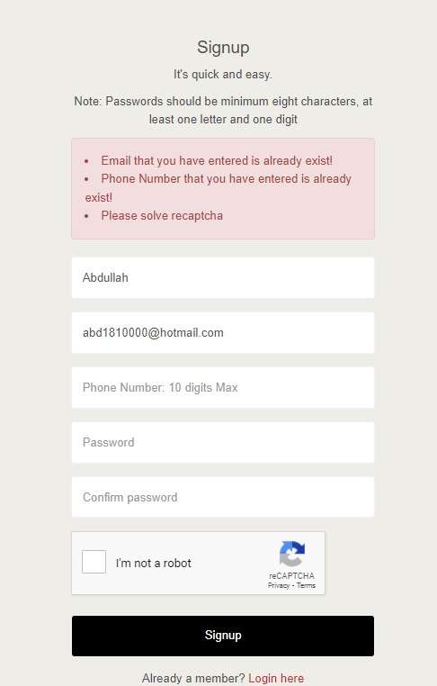
Figure 7: Email and Phone Number Already Exist
- If the user enters everything correctly without solving reCAPTCHA.
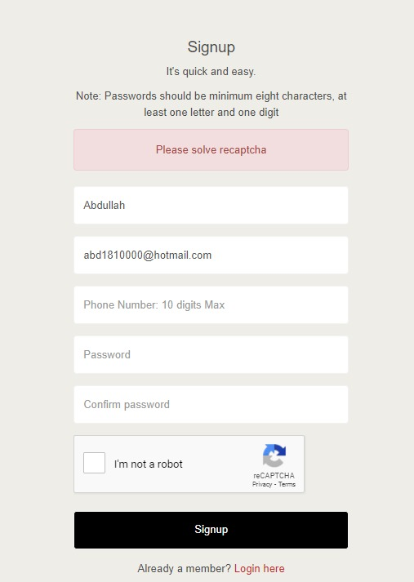
Figure 8: reCAPTCHA Error
- Otherwise
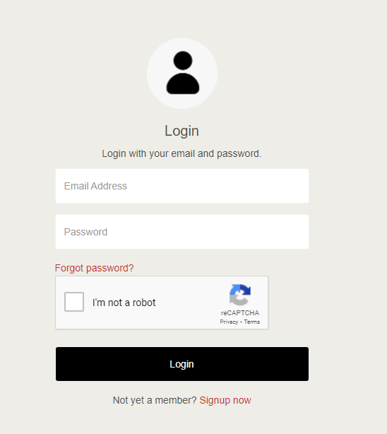
Figure 9: Login Page

Testing and Verification (Automation Testing)

Test 1 File (Sign Up Page)
We have a one fixture called Automate Registration
import { Selector } from "testcafe";
fixture `Auatomate Registration`
.page ('http://localhost/carrental/signup-user.php')

            - User registration (valid)
// User registration (valid)
test('User registration (valid)', async t=>{
await t

.typeText(Selector('#names'), 'Abdullah')
.typeText(Selector('#email'), 'abd1810000@hotmail.com')
.typeText(Selector('#phone'), '0563810177')
.typeText(Selector('#password'), '12345678Aa')
.typeText(Selector('#cpassword'), '12345678Aa')

.click(Selector('#bsignup'))
.wait(5000)
.expect(Selector('H2').withExactText('Login').exists).ok();

})

- Already Phone & Email exist
// Already Phone & Email exist
test('Already Phone & Email exist ', async t=>{
await t

.typeText(Selector('#names'), 'Abdullah')
.typeText(Selector('#email'), 'abd1810000@hotmail.com')
.typeText(Selector('#phone'), '0563810177')
.typeText(Selector('#password'), '12345678Aa')
.typeText(Selector('#cpassword'), '12345678Aa')

.click(Selector('#bsignup'))
.wait(5000)
.expect(Selector('H2').withExactText('Signup').exists).ok();

})

- Password does not match
// Password does not match

test('Password does not match', async t=>{
await t
.typeText(Selector('#names'), 'Abdullah')
.typeText(Selector('#email'), 'abd181@live.com')
.typeText(Selector('#phone'), '0563810133')
.typeText(Selector('#password'), '12345678Aa')
.typeText(Selector('#cpassword'), 'a23f5678Ac')

.click(Selector('#bsignup'))
.wait(5000)
.expect(Selector('H2').withExactText('Signup').exists).ok();

})
- Phone already exists

// Phone already exists

test('Phone already exists', async t=>{
await t
.typeText(Selector('#names'), 'Abdullah')
.typeText(Selector('#email'), 'abd181@live.com')
.typeText(Selector('#phone'), '0563810189')
.typeText(Selector('#password'), '12345678Aa')
.typeText(Selector('#cpassword'), '12345678Aa')

.click(Selector('#bsignup'))
.wait(5000)
.expect(Selector('H2').withExactText('Signup').exists).ok();

})
- Email already exists
// Email already exists

test('Email already exists', async t=>{
await t
.typeText(Selector('#names'), 'Abdullah')
.typeText(Selector('#email'), 'abd1810000@gmail.com')
.typeText(Selector('#phone'), '0563810155')
.typeText(Selector('#password'), '12345678Aa')
.typeText(Selector('#cpassword'), '12345678Aa')

.click(Selector('#bsignup'))
.wait(5000)
.expect(Selector('H2').withExactText('Signup').exists).ok();

});

The output
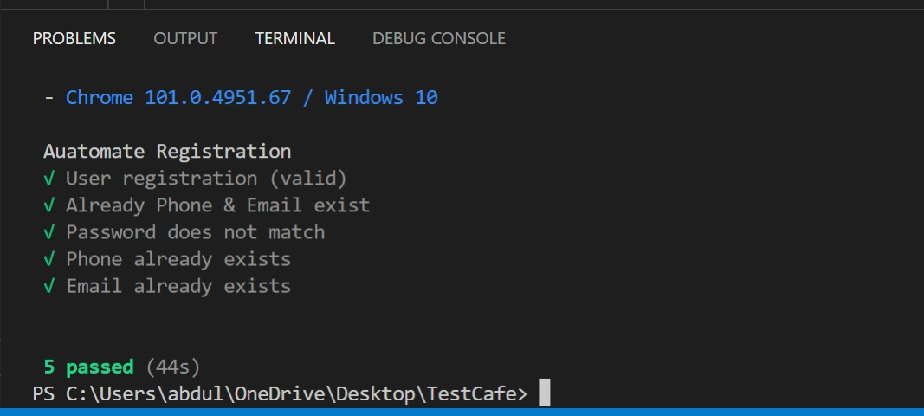
Figure 10: Test 1(the output)

Test 2 File (Sign Up Page)
We have a one fixture called Automate Registration
import { Selector } from "testcafe";
fixture `Auatomate Registration`

.page ('http://localhost/carrental/signup-user.php')
      - Invalid phone format

// Invalid phone format
test(' Invalid phone format', async t=>{
await t
.typeText(Selector('#names'), 'Abdullah')
.typeText(Selector('#email'), 'abd181@live.com')
.typeText(Selector('#phone'), '1234567890')
.typeText(Selector('#password'), '12345678Aa')
.typeText(Selector('#cpassword'), '12345678Aa')

.click(Selector('#bsignup'))
.wait(5000)
.expect(Selector('H2').withExactText('Signup').exists).ok();

})
      - Invalid password format
// Invalid password format
test(' Invalid password format', async t=>{
await t
.typeText(Selector('#names'), 'Abdullah')
.typeText(Selector('#email'), 'abd181@live.com')
.typeText(Selector('#phone'), '0563810111')
.typeText(Selector('#password'), '123')
.typeText(Selector('#cpassword'), '123')
.click(Selector('#bsignup'))
.wait(5000)
.expect(Selector('H2').withExactText('Signup').exists).ok();
})
      - Not filling out all the info
// Not filling out all the info
test('Not filling out all the info ', async t=>{
await t
// .typeText(Selector('#names'), 'Abdullah')
.typeText(Selector('#email'), 'abd181@live.com')
.typeText(Selector('#phone'), '0563810177')
.typeText(Selector('#password'), '12345678Aa')
.typeText(Selector('#cpassword'), '12345678Aa')

.click(Selector('#bsignup'))
.wait(5000)
.expect(Selector('H2').withExactText('Signup').exists).ok();
})

      - Already a member?

// Already a member?
test('Already a member?', async t=>{
await t
.wait(5000)
.click(Selector('#AlreadyMember'))
.wait(5000)
.expect(Selector('H2').withExactText('Login').exists).ok();

});

The output
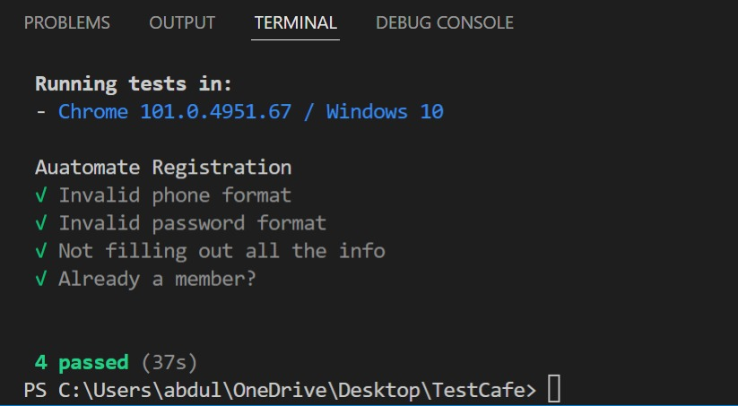
Figure 11: Test 2(the output)

Test 3 File (Login Page)
We have a one fixture called Automate Registration
import { Selector } from "testcafe";

fixture `Sign in`
.page ('http://localhost/carrental/login-user.php')
            - Valid Credentials
// Valid Credentials
test('Login and logout user with a valid email & password', async t=>{
await t
.typeText(Selector('#email'), 'abd1810000@hotmail.com')
.typeText(Selector('#password'), '12345678Aa')
.click(Selector('#blogin'))
.wait(5000)
.expect(Selector('H2').withExactText('Cars').exists).ok()
.click(Selector('#logout'))

.expect(Selector('H2').withExactText('Login').exists).ok();

})

            - Invalid Email & Password
// Invalid Email & Password

test('Login user with invalid email & password', async t=>{
await t
.typeText(Selector('#email'), 'test@hotmail.com')
.typeText(Selector('#password'), '12345678bb')
.click(Selector('#blogin'))
.wait(5000)
.expect(Selector('H2').withExactText('Login').exists).ok()

})

            - Invalid Password
// Invalid Password

test('Login user with an invalid password', async t=>{
await t
.typeText(Selector('#email'), 'abd1810000@hotmail.com')
.typeText(Selector('#password'), '12345678bb')
.click(Selector('#blogin'))
.wait(5000)
.expect(Selector('H2').withExactText('Login').exists).ok()
})

- Click on login button with filling out the credentials
// Click on login button with filling out the credentials

test('Not filling out the credentials', async t=>{
await t

.click(Selector('#blogin'))
.wait(5000)
.expect(Selector('H2').withExactText('Login').exists).ok()
})

- Invalid Email

// Invalid Email

test('Login user with invalid email', async t=>{
await t
.typeText(Selector('#email'), 'test@hotmail.com')
.typeText(Selector('#password'), '12345678bb')
.click(Selector('#blogin'))
.wait(5000)
.expect(Selector('H2').withExactText('Login').exists).ok()
});

The output
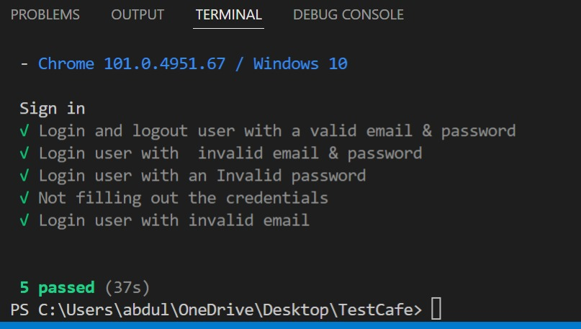
Figure 12: Test 3(the output)

References
[1] Getting started. Docs. (n.d.). Retrieved May 25, 2022, from https://testcafe.io/documentation/402635/getting-started

